* Copyright for test papers and marking guides remains with *West Australian Test Papers*.
* The papers may only be reproduced within the purchasing school according to the advertised conditions of sale.
* Test papers must be withdrawn after use and stored securely in the school until 6 December

**HUMAN BIOLOGY**

**Unit 1 and 2**

**2019**



Name:_______________________________________________________

Teacher: ___________________________________________________

**Time allowed for this paper**

Reading time before commencing work: ten minutes

Working time for the paper: three hours

**Materials required/recommended for this paper**

***To be provided by the supervisor***

This Question/Answer booklet

Multiple-choice answer sheet

***To be provided by the candidate:***

Standard items: pens (blue/black preferred), pencils (including coloured), sharpener, correction

fluid/tape, eraser, ruler, highlighters

Special items: non-programmable calculators approved for use in this examination

**Important note to candidates**

No other items may be taken into the examination room. It is **your** responsibility to ensure that you do not have any unauthorised material. If you have any unauthorised material with you, hand it to the supervisor **before** reading any further.

**Structure of this paper**

|  |  |  |  |  |  |
| --- | --- | --- | --- | --- | --- |
| Section | Number of questions available | Number of questions to be answered | Suggested working time (minutes) | Marks available | Percentage of examination |
| Section One  Multiple-choice | 30 | 30 | 40 | 30 | 30 |
| Section Two  Short answers | 8 | 8 | 90 | 100 | 50 |
| Section Three  Extended answers | 3 | 2 | 50 | 40 | 20 |
|  |  |  |  | **Total** | 100 |

**Instructions to candidates**

1. The rules for the conduct of the Western Australian examinations are detailed in the *Year 12 Information Handbook 2019*. Sitting this examination implies that you agree to abide by these rules.

2. Write your answers in this Question/Answer booklet preferably using a blue/black pen. Do not use erasable or gel pens.

3. Answer the questions according to the following instructions.

Section One: Answer all questions on the separate Multiple-choice answer sheet provided. For each question, shade the box to indicate your answer. Use only a blue or black pen to shade the boxes. Do not use erasable or gel pens. If you make a mistake, place a cross through that square, then shade your new answer. Do not erase or use correction fluid/tape. Marks will not be deducted for incorrect answers. No marks will be given if more than one answer is completed for any question.

Section Two: Write your answers in this Question/Answer booklet. Wherever possible, confine your answers to the line spaces provided.

Section Three: Consists of three questions. You must answer two questions. Tick the box next to the question you are answering. Write your answers in this Question/Answer booklet.

4. You must be careful to confine your answers to the specific questions asked and to follow any instructions that are specific to a particular question.

5. Supplementary pages for planning/continuing your answers to questions are provided at the end of this Question/Answer booklet. If you use these pages to continue an answer, indicate at the original answer where the answer is continued, i.e. give the page number.

**Section One: Multiple–choice 30% (30 Marks)**

This section has **30** questions. Answer **all** questions on the separate Multiple-choice Answer Sheet provided. For each question shade the box to indicate your answer. Use only a blue or black pen to shade the boxes. Do not use erasable or gel pens. If you make a mistake, place a cross through that square, then shade your new answer. Do not erase or use correction fluid/tape. Marks will not be deducted for incorrect answers. No marks will be given if more than one answer is completed for any question.

Suggested working time: 40 minutes

1. In a DNA molecule, adenine pairs with

(a) adenine.

(b) guanine.

(c) thymine.

(d) uracil.

2. Muscle tissue may be smooth or striated. Smooth muscle would be found in the

(a) intestinal and bronchial walls.

(b) facial muscles.

(c) heart muscle.

(d) limb muscles.

3. The process by which fatty acids and glycerol enter a lacteal via a villus is

(a) active transport.

(b) diffusion.

(c) osmosis.

(d) endocytosis.

4. The chemical element that is found in all amino acids but is not found in either carbohydrates or lipids is

(a) oxygen.

(b) carbon.

(c) nitrogen.

(d) hydrogen.

5. If a mutation occurred within a dominant allele it

(a) would spread slower through a population than a recessive mutation.

(b) would cause many deaths.

(c) would be seen less often in the population’s phenotypes.

(d) could give an observable phenotype within a heterozygous individual.

6. How many sex chromosomes does a normal female inherit from her mother?

(a) 46

(b) 2

(c) 23

(d) 1

Question 7 relates to the information and tables below:

Students were asked to design an investigation to determine the effect of changing pH levels on enzyme activity. Four students’ designs are shown below.

E = Enzyme

S = Substrate

**Design I Design III**

|  |  |  |  |
| --- | --- | --- | --- |
| **Tube number** | **Contents** | **pH** | **Temp (℃)** |
| 1 | E | 3 | 20 |
| 2 | E | 7 | 20 |
| 3 | E | 12 | 20 |
| 4 | S | 3 | 20 |
| 5 | S | 7 | 20 |
| 6 | S | 12 | 20 |

|  |  |  |  |
| --- | --- | --- | --- |
| **Tube number** | **Contents** | **pH** | **Temp (℃)** |
| 1 | E+S | 3 | 20 |
| 2 | E+S | 7 | 20 |
| 3 | E+S | 12 | 20 |
| 4 | S | 3 | 20 |
| 5 | S | 7 | 20 |
| 6 | S | 12 | 20 |

**Design II Design IV**

|  |  |  |  |
| --- | --- | --- | --- |
| **Tube number** | **Contents** | **pH** | **Temp (℃)** |
| 1 | E+S | 3 | 10 |
| 2 | E+S | 7 | 20 |
| 3 | E+S | 12 | 30 |
| 4 | S | 3 | 20 |
| 5 | S | 7 | 30 |
| 6 | S | 12 | 10 |

|  |  |  |  |
| --- | --- | --- | --- |
| **Tube number** | **Contents** | **pH** | **Temp (℃)** |
| 1 | E+S | 3 | 10 |
| 2 | E+S | 7 | 10 |
| 3 | E+S | 7 | 30 |
| 4 | E | 12 | 10 |
| 5 | E | 12 | 20 |
| 6 | S | 12 | 30 |

7. Which investigation design is the most appropriate?

(a) Design I

(b) Design II

(c) Design III

(d) Design IV

8. Which of the following comparisons between arteries and veins is **not** correct?

|  |  |  |
| --- | --- | --- |
|  | **Arteries** | **Veins** |
| (a) | thick and muscular walls | thin walls |
| (b) | blood at high pressure | blood at low pressure |
| (c) | valves present | valves absent |
| (d) | usually contains blood with low carbon dioxide | usually contains blood with high carbon dioxide |

9. A student completed a genetic exercise by preparing the Punnett square shown below.

**Parent 1 gametes**

|  |  |
| --- | --- |
| TT | Tt |
| Tt | Tt |

**Parent 2**

**gametes**

What were the likely genotypes of the parents?

(a) Parent 1 was homozygous while Parent 2 was heterozygous.

(b) Parent 1 was heterozygous while Parent 2 was homozygous.

(c) Both parents were heterozygous for the trait.

(d) Both parents were homozygous for the trait.

10. An investigation was carried out looking at changes to the composition of blood as it flowed through various organs of the body. Data from one of the organs tested showed an increase in both carbon dioxide and by-products of the digestion process, but a decrease in oxygen levels.

Which of the following organs would be most likely to produce this result?

(a) lungs

(b) small intestine

(c) gall bladder

(d) kidney

11. Variation that occurs as a result of meiosis can be due to

(a) equal numbers of chromosomes.

(b) teratogens.

(c) random mating.

(d) crossing over.

12. The following is a list of steps that occurs in the process of mitosis:

i) formation of two daughter cells

ii) separation of the chromatids

iii) duplication of chromosomes

iv) division of the cytoplasm

v) chromatid pairs line up along the equator of the cell

Which of the following is the correct order of events in mitosis?

(a) i, ii, iii, iv, v

(b) iv, iii, v, ii, i

(c) v, iv, iii, ii, i

(d) iii, v, ii, iv, i

13. Men are more likely to suffer from sex-linked genetic conditions than women because

* + - 1. males carry the Y chromosome.
      2. most X-linked conditions are dominant.
      3. males possess only one X chromosome.
      4. the Y chromosome carries little body information other than “maleness”.

14. In a controlled experiment, a scientist is studying the effect of increasing the resistance whilst pedalling an exercise bike on heart rate and stroke volume. What is the dependent variable?

* 1. the time spent on the bike
  2. the resistance to pedalling the bike
  3. the type of exercise bike
  4. the heart rate and stroke volume

Question 15 refers to the table below:

A group of Year 10 pupils carried out a survey of their class. The numbers of attached ear lobes

and unattached ear lobes in the class were counted and recorded. The table below shows the

results.

|  |  |
| --- | --- |
| **Number of pupils** | |
| **Attached ear lobes** | **Unattached ear lobes** |
| 17 | 3 |

15. What type of graph should they use to best represent the data?

(a)line graph

(b) bar graph

(c) histogram

(d) scatter graph

16. Spermatogenesis is the development of

(a) eggs.

(b) mature sperm.

(c) gametes.

(d) spermatid

17. Stage three of the labour process involves the

(a) contractions of the uterus, and expulsion of the placenta.

(b) contraction of the uterus and production of colostrum in the breast.

(c)the expulsion of the baby from the birth canal.

(d) an increase in uterine contractions.

Questions 18 and 19 refer to the diagram below:

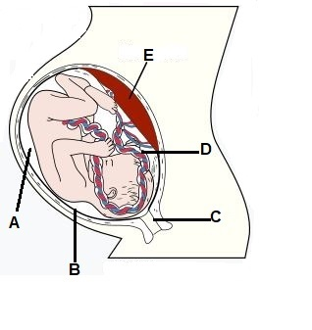

18. The structure labelled as D is the

(a) amnion.

(b) umbilical cord.

(c) placenta.

(d) chorion.

19. Which of the structure/s labelled would help protect the baby from damage?

(a) A and B

(b) B and C

(c) C, D and E

(d) E only

20. The function of bile is to

(a) emulsify lipids in the large intestine.

(b) digest lipids in the stomach.

(c) emulsify lipids in the small intestine.

(d) digest starches in the stomach.

Questions 21 and 22 refer to the diagram below:

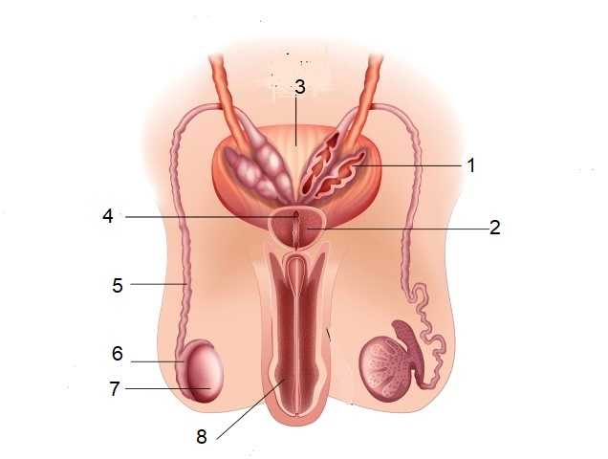

21. Which of the structure/s labelled above function as part of the reproductive and excretory systems?

(a) 3 and 7

(b) 8 only

(c) 5 only

(d) 1 and 8

22. The function of the structure labelled as “6” is to

(a) produce components of semen.

(b) produce testosterone.

(c) store sperm.

(d) connect the seminal vesicles to the prostate gland.

23. The structure within the kidney responsible for producing urine is the

(a) nephron.

(b) ureter.

(c) renal calyx.

(d) bladder.

24. The cartilage found at the end of long bones that decreases friction at joint surfaces is called

(a) articular.

(b) inelastic.

(c) elastic.

(d) synovial.

25. Which of the following is **not** an advantage of breast feeding a baby?

(a) infants receive antibodies from their mothers’ milk.

(b) mothers are able to determine exactly how much their baby has consumed.

(c) breast milk is always at the correct temperature.

(d) breast milk does not need to be sterilised.

26. When using a light microscope, the magnification can be altered by

(a) changing the light intensity.

(b) changing the objective lens.

(c) moving the position of the stage.

(d) changing the coarse focus.

27. Although the heart beats intermittently, the blood pressure in the arteries does not drop to zero between beats of the heart and the blood is kept in continuous motion.

Which of the following best explains these observations?

(a) The left and right ventricles contract alternately.  
 (b) Blood is held in reserve in the lymphatic system and supplements blood flow when required.  
 (c) The blood changes in volume with the pressure changes produced by periodic contractions.  
 (d) The walls of the arteries are elastic.

28. The ectoderm layer develops into several body systems and organs in an embryo. This includes the

(a) reproductive system.

(b) nervous system.

(c) skeletal muscles.

(d) bones.

29. The lymphatic system

(a) contains platelets that assist in blood clotting.

(b) releases fluid to maintain blood volume.

(c) helps in the digestion of proteins.

(d) contains cells that help defend the body against infection.

30. Which of the following foods would be chemically digested to the greatest extent in the stomach?

(a) A slice of bread  
(b) An apple  
(c) A carrot  
(d) An egg

**End of Section One**

**Section Two: Short answer 50% (100 Marks)**

This section has **eight** questions. Answer **all** questions. Write your answers in the spaces provided.

Supplementary pages for the use of planning/continuing your answer to a question have been provided at the end of this Question/Answer booklet. If you use these pages to continue an answer, indicate at the original answer where the answer is continued, i.e. give the page number.

Suggested working time: 90 minutes.

**Question 31**  **(10 marks)**

Cell metabolism is crucial to the survival of cells. Many components of a cell are involved in maintaining cell metabolic activity.

Refer to the following diagram to answer the questions that follow.

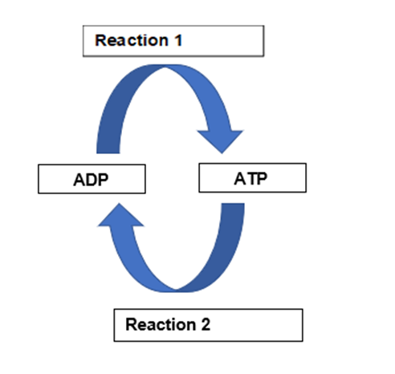

(a) Name a cellular process that will provide the energy for Reaction 1 to occur. (1 mark)

______________________________________________________________________

(b) Describe what is occurring in Reaction 2 and identify why this reaction is important to cells. (2 marks)

___________________________________________________________________________________________________________________________________­­­­­­­­­­­­­­_________

(c) During vigorous physical activity the body has an increased demand for energy to fuel the contracting muscles. Often this cannot be sustained by the respiratory and circulatory systems.

(i) How then is the body able to generate energy in this situation? (1 mark)

________________________________________________________________

(ii) State where this process occurs and what the end product is. (2 marks)

________________________________________________________________

________________________________________________________________

(d) Mitochondria are organelles found within the cell. Mitochondria have a specialized structure that enables them to carry out their function. State why having a highly folded inner membrane and a highly permeable outer membrane would assist mitochondria in their function. (2 marks)

___________________________________________________________________________________________________________________________________­­­­­­­­­­­­­­_________

___________________________________________________________________________________________________________________________________­­­­­­­­­­­­­­_________

(e) Carbohydrates and lipids are important nutrients that can be used to create energy within cells. Explain which of the two is a better energy reserve. (2 marks)

___________________________________________________________________________________________________________________________________­­­­­­­­­­­­­­_________

___________________________________________________________________________________________________________________________________­­­­­­­­­­­­­­_________

**Question 32 (13 marks)**

Some Human Biology students were investigating the effect of drinking various solutions on

urine output. The two solutions they used were 1 L of plain water and 1L of an isotonic

sodium chloride solution. After drinking the solutions, they measured urine output every 30

minutes for 3 hours. Their results are shown below.

|  |  |  |
| --- | --- | --- |
| **Time (min)** | **Urine output (cm3/30 min)** | |
| **Plain water** | **Sodium chloride solution** |
| Start (solutions drunk) |  |  |
| 30 | 40 | 30 |
| 60 | 350 | 40 |
| 90 | 450 | 50 |
| 120 | 250 | 60 |
| 150 | 80 | 70 |
| 180 | 60 | 50 |

(a) Propose a hypothesis for this investigation. (1 mark)

___________________________________________________________________________________________________________________________________­­­­­­­­­­­­­­_________

(b) Identify the following variables for the students’ investigation:

(i) Independent variable (2 marks)

________________________________________________________________

(ii) Dependent variable

________________________________________________________________

(c) Graph the data on the grid provided. (5 marks)

(A spare grid can be found at the back of the exam if you wish to have a second attempt).

|  |  |  |  |  |  |  |  |  |  |  |  |  |  |  |  |  |  |  |  |  |  |  |  |  |
| --- | --- | --- | --- | --- | --- | --- | --- | --- | --- | --- | --- | --- | --- | --- | --- | --- | --- | --- | --- | --- | --- | --- | --- | --- |
|  |  |  |  |  |  |  |  |  |  |  |  |  |  |  |  |  |  |  |  |  |  |  |  |  |
|  |  |  |  |  |  |  |  |  |  |  |  |  |  |  |  |  |  |  |  |  |  |  |  |  |
|  |  |  |  |  |  |  |  |  |  |  |  |  |  |  |  |  |  |  |  |  |  |  |  |  |
|  |  |  |  |  |  |  |  |  |  |  |  |  |  |  |  |  |  |  |  |  |  |  |  |  |
|  |  |  |  |  |  |  |  |  |  |  |  |  |  |  |  |  |  |  |  |  |  |  |  |  |
|  |  |  |  |  |  |  |  |  |  |  |  |  |  |  |  |  |  |  |  |  |  |  |  |  |
|  |  |  |  |  |  |  |  |  |  |  |  |  |  |  |  |  |  |  |  |  |  |  |  |  |
|  |  |  |  |  |  |  |  |  |  |  |  |  |  |  |  |  |  |  |  |  |  |  |  |  |
|  |  |  |  |  |  |  |  |  |  |  |  |  |  |  |  |  |  |  |  |  |  |  |  |  |
|  |  |  |  |  |  |  |  |  |  |  |  |  |  |  |  |  |  |  |  |  |  |  |  |  |
|  |  |  |  |  |  |  |  |  |  |  |  |  |  |  |  |  |  |  |  |  |  |  |  |  |
|  |  |  |  |  |  |  |  |  |  |  |  |  |  |  |  |  |  |  |  |  |  |  |  |  |
|  |  |  |  |  |  |  |  |  |  |  |  |  |  |  |  |  |  |  |  |  |  |  |  |  |
|  |  |  |  |  |  |  |  |  |  |  |  |  |  |  |  |  |  |  |  |  |  |  |  |  |
|  |  |  |  |  |  |  |  |  |  |  |  |  |  |  |  |  |  |  |  |  |  |  |  |  |
|  |  |  |  |  |  |  |  |  |  |  |  |  |  |  |  |  |  |  |  |  |  |  |  |  |
|  |  |  |  |  |  |  |  |  |  |  |  |  |  |  |  |  |  |  |  |  |  |  |  |  |
|  |  |  |  |  |  |  |  |  |  |  |  |  |  |  |  |  |  |  |  |  |  |  |  |  |
|  |  |  |  |  |  |  |  |  |  |  |  |  |  |  |  |  |  |  |  |  |  |  |  |  |
|  |  |  |  |  |  |  |  |  |  |  |  |  |  |  |  |  |  |  |  |  |  |  |  |  |
|  |  |  |  |  |  |  |  |  |  |  |  |  |  |  |  |  |  |  |  |  |  |  |  |  |
|  |  |  |  |  |  |  |  |  |  |  |  |  |  |  |  |  |  |  |  |  |  |  |  |  |
|  |  |  |  |  |  |  |  |  |  |  |  |  |  |  |  |  |  |  |  |  |  |  |  |  |
|  |  |  |  |  |  |  |  |  |  |  |  |  |  |  |  |  |  |  |  |  |  |  |  |  |

(d) State **two** ways in which errors could have occurred that may affect the accuracy of the results. (2 marks)

___________________________________________________________________________________________________________________________________­­­­­­­­­­­­­­_________

______________________________________________________________________

____________________________________________________________________­­­­­­­­­­­­­­__

(e) In humans the average amount of glomerular filtrate formed in one hour is 7L. In one hour the average amount of urine produced is approximately 75mL.

(i) Name the process occurring in the nephron that brings about this difference in volume. (1 mark)

________________________________________________________________

(ii) Explain why the process identified in part (i) must occur in the human body (2 marks)

________________________________________________________________ ________________________________________________________________

**Question 33 (14 marks)**

Shown below is a pedigree that outlines the inheritance of a particular disease within a family.

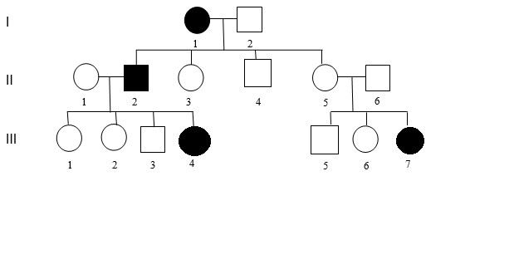

(a) Using evidence from the pedigree, explain why the disorder cannot be transmitted by a sex-linked recessive gene. (2 marks)

___________________________________________________________________________________________________________________________________­­­­­­­­­­­­­­_________

______________________________________________________________________

(b) Using evidence from the pedigree, explain why the disorder cannot be transmitted by an autosomal dominant gene. (2 marks)

___________________________________________________________________________________________________________________________________­­­­­­­­­­­­­­_________

______________________________________________________________________

(c) Assume that the individual II 1 has a genotype **Bb**. Individuals II 1 and II 2 have another child. What is the probability that the child will be an affected daughter? Show your working. (4 marks)

(d) Which male in generation 3 is more **unlikely** to pass on the allele to his future children? Explain your reasoning. (3 marks)

___________________________________________________________________________________________________________________________________­­­­­­­­­­­­­­_________

____________________________________________________________________________________________________________________________________________­­­­­­­­­­­­­­

______________________________________________________________________

(e) If ll5 becomes pregnant again, describe **one** prenatal test this couple could have to find out the genotype of the unborn child and state **one** risk associated with this method of prenatal testing. (3 marks)

___________________________________________________________________________________________________________________________________­­­­­­­­­­­­­­_________

______________________________________________________________________

**Question 34 (11 marks)**

Paternity testing involves a number of procedures used to determine the biological father of a child. One of these is testing for blood groups while the other looks at DNA profiling.

The following shows some results for these two procedures.

**Procedure 1: Testing for ABO blood groups**

Mother’s blood group: B

Child’s blood group: O

Possible biological father’s blood groups – Father 1: O, Father 2: A, Father 3: B

**Procedure 2: DNA profile data**

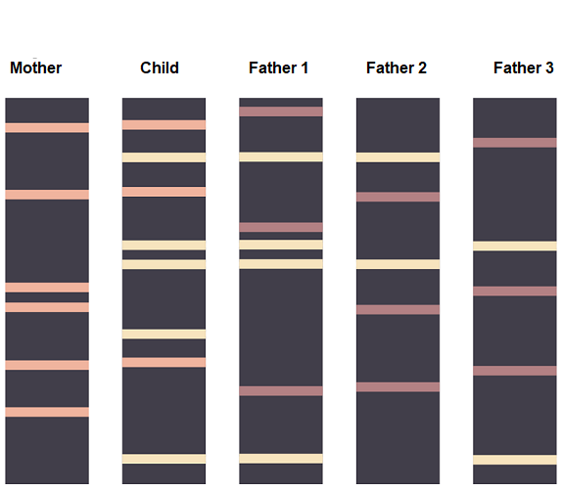

(a) (i) From the ABO blood group data, identify which male(s), can be

excluded as the possible biological father of the child. (1 mark)

________________________________________________________________

(ii) Using Punnett squares, show how you arrived at your answer in part (a)(i). (4 marks)

(b) Describe the process that produces DNA profile data.

(4 marks)

___________________________________________________________________________________________________________________________________­­­­­­­­­­­­­­_________

____________________________________________________________________________________________________________________________________________­­­­­­­­­­­­­­

___________________________________________________________________________________________________________________________________­­­­­­­­­­­­­­_________

____________________________________________________________________________________________________________________________________________­­­­­­­­­­­­­­

(c) Using the data from the DNA profile, suggest which of the fathers is the actual father of the child. Explain how you arrived at your answer. (2 marks)

___________________________________________________________________________________________________________________________________­­­­­­­­­­­­­­_________

_____________________________________________________________­­­­­­­­­­­­­­_________

______________________________________________________________________

**Question 35 (11 marks)**

(a) On the diagram of the heart shown below, label the aorta, the pulmonary artery and the right ventricle. (3 marks)

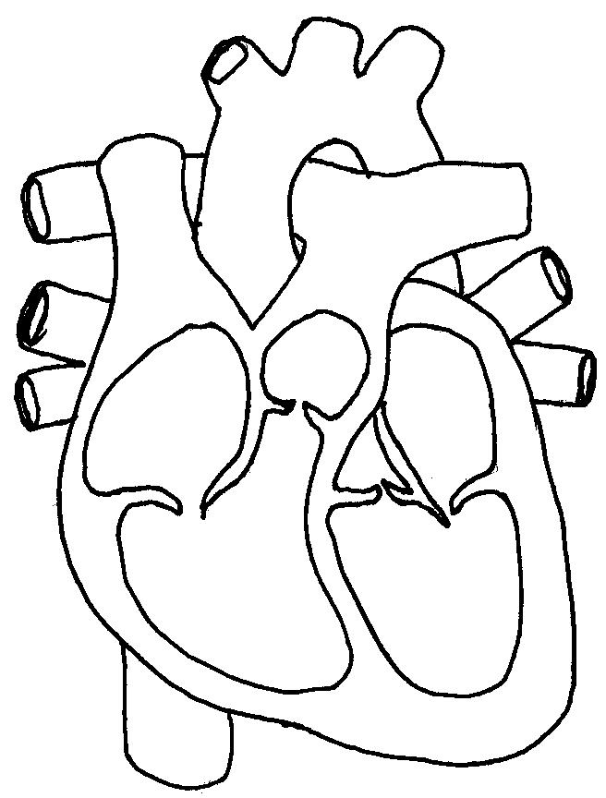

(b) All babies are born with a “hole in their heart” that closes over once the lungs inflate with oxygen. What name is given to this structure? (1 mark)

________________________________________________________________­­­­____

Occasionally a baby is born with a serious condition of the heart. There are separate abnormalities within the heart that occur as a result of this condition including that the aorta comes primarily out of the right ventricle instead of the left and the muscular wall between the right and left sides of the heart is incomplete, so the blood in the left and right ventricles is not kept separate.

(c) In a baby with the condition described above, is the hole between the ventricles an advantage or a disadvantage? Explain your choice. (3 marks)

___________________________________________________________________________________________________________________________________­­­­­­­­­­­­­­_________

____________________________________________________________________________________________________________________________________________­­­­­­­­­­­­­­

(d) Many vital organs of a foetus are not required to function whilst it is carried in the uterus. After birth, however, rapid changes need to occur within the foetal circulation to enable the baby to survive outside the womb. Outline **two** major changes (besides the hole in the heart closing) that will occur.

(4 marks)

___________________________________________________________________________________________________________________________________­­­­­­­­­­­­­­_________

________________________________________________________________________________________________________________________________________________________________________________________________________________________________________________________________________________________­­­­­­­­­­­­­­

**Question 36 (12 marks)**

(a) Sketch a graph that shows the changes in thickness of the uterine wall throughout one complete menstrual cycle. Indicate on the graph when ovulation occurs. (2 marks)

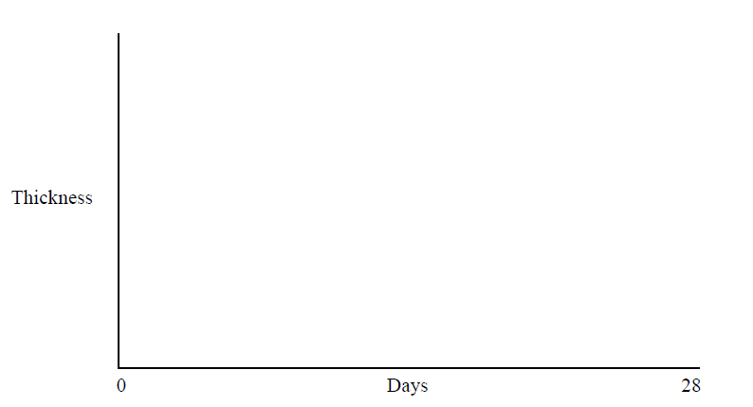

(b) Describe how the following hormones affect the uterine lining (endometrium) during the monthly cycle.

(2 marks)

(i) Progesterone

________________________________________________________________ ________________________________________________________________

(ii) Oestrogen

________________________________________________________________ ________________________________________________________________

(c)  How does fertilisation of an egg alter the hormonal regulation menstrual cycle?

(5 marks)

___________________________________________________________________________________________________________________________________­­­­­­­­­­­­­­_________

___________________________________________________________________________________________________________________________________­­­­­­­­­­­­­­_________

___________________________________________________________________________________________________________________________________­­­­­­­­­­­­­­_________

______________________________________________________________________

(d) About 1 in 6 couples in Australia wanting to have children experience difficulties in getting pregnant. Advancements in reproductive technology have resulted in a range of treatments for infertility being made available. One such assisted reproductive technology is GIFT.

(i) What does GIFT stand for? (1 mark)

________________________________________________________________ ________________________________________________________________

(ii) Describe how this procedure takes place. (2 marks)

________________________________________________________________ ________________________________________________________________

________________________________________________________________ ________________________________________________________________

**Question 37 (18 marks)**

(a) Starting just after birth, cartilage found within bones is progressively replaced by bone.

(i) What name is given to this process? (1 mark)

________________________________________________________________

(ii) How can we use the epiphyseal cartilage found inside long bones to determine when this process is complete? (3 marks)

________________________________________________________________ ________________________________________________________________

________________________________________________________________ ________________________________________________________________

The diagram below shows the bones found within the leg.

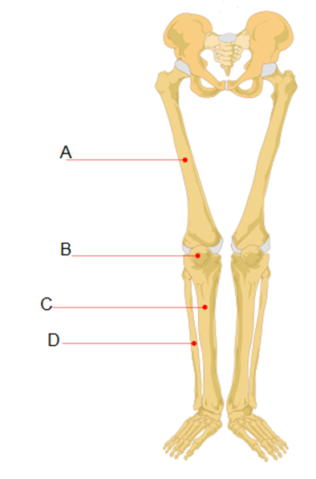

(b) Name the bone labelled A and state in which section of the skeleton you would find this bone. (2 marks)

______________________________________________________________________ ______________________________________________________________________

(c) People often think that bone is dead. Explain why this is not a true statement. (2 marks)

___________________________________________________________________________________________________________________________________­­­­­­­­­­­­­­_________

______________________________________________________________________

The movements at any particular joint are possible because of its structure, the location of ligaments and tendons, and the skeletal muscles that contract to pull the bone into a different position.

(d) The knee joint is an example of a synovial joint. What are **two** characteristics of all synovial joints? (2 marks)

___________________________________________________________________________________________________________________________________­­­­­­­­­­­­­­_________

______________________________________________________________________

(e) (i) Define the term ligament. (1 mark)

________________________________________________________________ ________________________________________________________________

(ii) Explain why tendons need to be inelastic. (3 marks)

________________________________________________________________ ________________________________________________________________

________________________________________________________________

(f) Muscle contraction is often explained by using the sliding filament model. Describe what would occur within a sarcomere to produce contraction. (4 marks)

___________________________________________________________________________________________________________________________________­­­­­­­­­­­­­­_________

____________________________________________________________________________________________________________________________________________­­­­­­­­­­­­­­

____________________________________________________________________________________________________________________________________________­­­­­­­­­­­­

**Question 38 (11 marks)**

1. DNA is made of units called nucleotides. Draw a labelled diagram of a nucleotide to show its constituent parts. (3 marks)
2. Which of the labelled part/s in your diagram may vary from nucleotide to nucleotide?

(1 mark)

______________________________________________________________________

DNA codes for the sequence of amino acids in a protein. The diagram below shows a section of a DNA strand.

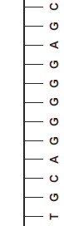

(c) (i) Use the base pair rule to create the complementary DNA strand. Draw it on the diagram above. (1 mark)

(ii) Write down the strand that would be produced from the DNA template to form mRNA. (1 mark)

______________________________________________________________________

(d) Describe in detail how mRNA is created from the DNA template strand.

(5 marks)

____________________________________________________________________________________________________________________________________________

____________________________________________________________________________________________________________________________________________

____________________________________________________________________________________________________________________________________________

______________________________________________________________________

______________________________________________________________________

______________________________________________________________________

______________________________________________________________________

______________________________________________________________________

**End of Section Two**

**Section Three: Extended answer 20% (40 Marks)**

This section contains **three** questions. You must answer **two** questions. Write your answers on the pages following Question 41.

Supplementary pages for planning/continuing your answers to questions are provided at the end of this Question/Answer booklet. If you use these pages to continue an answer, indicate at the original answer where the answer is continued, i.e. give the page number.

Suggested working time: 50 minutes.

Answer any **two** questions from Questions 39 to 41.

Indicate the questions you will answer by ticking the box next to the question. Write your answers on the pages that follow.

**Question 39 (20 marks)**

(a) In the human body the functioning of the different body systems is closely related to the structure of the tissues and organs that connect together to create the system. For each of the following, describe the structure of the component and explain how the structure is responsible for the functioning of the system in which it is found. (12 marks)

(i) Alveolus

(ii) Nephron

(iii) Villus

(b) Enzymes are involved in chemical reactions that occur within cells. Explain why there is a need for so many different enzymes in the body and outline how they work. (8 marks)

** Question 40 (20 marks)**

(a) Movement or motion takes place as a coordinated action between muscles, bones and joints. Describe in detail how the processes of flexion and extension occur at the elbow joint. (12 marks)

(b) Stem cells are promoted as “the way of the future” for the treatment of many illnesses. Define the term stem cell and explain **three** differences between adult and embryonic stem cells. (8 marks)

** Question 41 (20 marks)**

(a) During pregnancy a vital structure called the placenta is formed that provides a link between the foetus and the mother. Explain the functions of the placenta during pregnancy. (8 marks)

(b) Modern science has introduced new and highly reliable methods of birth control or contraception. A condom is a mechanical barrier whilst the oral contraceptive pill is a chemical method. Discuss in detail how each of the named contraceptives work to prevent pregnancy, and the advantages and disadvantages of each. (12 marks)

**End of Examination**

Question Number­­­­­­­­­­­_______________________

__________________________________________________________________________________________________________________________________________________­­­_____

_________________________________________________________________________­­­___

_________________________________________________________________________­­­___

____________________________________________________________________________

____________________________________________________________________________

________________________________________________________________________________________________________________________________________________________

____________________________________________________________________________

____________________________________________________________________________

____________________________________________________________________________

____________________________________________________________________________

________________________________________________________________________________________________________________________________________________________

____________________________________________________________________________

____________________________________________________________________________

____________________________________________________________________________

____________________________________________________________________________

________________________________________________________________________________________________________________________________________________________

____________________________________________________________________________

____________________________________________________________________________

____________________________________________________________________________

____________________________________________________________________________

________________________________________________________________________________________________________________________________________________________

________________________________________________________________________________________________________________________________________________________

Question Number­­­­­­­­­­­_______________________

__________________________________________________________________________________________________________________________________________________­­­_____

_________________________________________________________________________­­­___

_________________________________________________________________________­­­___

____________________________________________________________________________

____________________________________________________________________________

________________________________________________________________________________________________________________________________________________________

____________________________________________________________________________

____________________________________________________________________________

____________________________________________________________________________

____________________________________________________________________________

________________________________________________________________________________________________________________________________________________________

____________________________________________________________________________

____________________________________________________________________________

____________________________________________________________________________

____________________________________________________________________________

________________________________________________________________________________________________________________________________________________________

____________________________________________________________________________

____________________________________________________________________________

____________________________________________________________________________

____________________________________________________________________________

________________________________________________________________________________________________________________________________________________________

________________________________________________________________________________________________________________________________________________________

Question Number _____________________

__________________________________________________________________________________________________________________________________________________­­­_____

_________________________________________________________________________­­­___

_________________________________________________________________________­­­___

____________________________________________________________________________

____________________________________________________________________________

________________________________________________________________________________________________________________________________________________________

____________________________________________________________________________

____________________________________________________________________________

____________________________________________________________________________

____________________________________________________________________________

________________________________________________________________________________________________________________________________________________________

____________________________________________________________________________

____________________________________________________________________________

____________________________________________________________________________

____________________________________________________________________________

________________________________________________________________________________________________________________________________________________________

____________________________________________________________________________

____________________________________________________________________________

____________________________________________________________________________

____________________________________________________________________________

________________________________________________________________________________________________________________________________________________________

______________________________________________________________________­­­___

_________________________________________________________________________­­­___

Question Number­­­­­­­­­­­_______________________

____________________________________________________________________________

____________________________________________________________________________

________________________________________________________________________________________________________________________________________________________

____________________________________________________________________________

____________________________________________________________________________

____________________________________________________________________________

____________________________________________________________________________

________________________________________________________________________________________________________________________________________________________

____________________________________________________________________________

____________________________________________________________________________

____________________________________________________________________________

____________________________________________________________________________

________________________________________________________________________________________________________________________________________________________

____________________________________________________________________________

____________________________________________________________________________

____________________________________________________________________________

____________________________________________________________________________

________________________________________________________________________________________________________________________________________________________

__________________________________________________________________________________________________________________________________________________­­­_____

_________________________________________________________________________­­­___

_________________________________________________________________________­­­___

____________________________________________________________________________

____________________________________________________________________________

Question Number­­­­­­­­­­­_______________________

________________________________________________________________________________________________________________________________________________________

____________________________________________________________________________

____________________________________________________________________________

____________________________________________________________________________

____________________________________________________________________________

________________________________________________________________________________________________________________________________________________________

____________________________________________________________________________

____________________________________________________________________________

____________________________________________________________________________

____________________________________________________________________________

________________________________________________________________________________________________________________________________________________________

____________________________________________________________________________

____________________________________________________________________________

____________________________________________________________________________

____________________________________________________________________________

________________________________________________________________________________________________________________________________________________________

__________________________________________________________________________________________________________________________________________________­­­_____

_________________________________________________________________________­­­___

_________________________________________________________________________­­­___

____________________________________________________________________________

____________________________________________________________________________

________________________________________________________________________________________________________________________________________________________

Question Number­­­­­­­­­­­_______________________

____________________________________________________________________________

____________________________________________________________________________

____________________________________________________________________________

____________________________________________________________________________

________________________________________________________________________________________________________________________________________________________

____________________________________________________________________________

____________________________________________________________________________

____________________________________________________________________________

____________________________________________________________________________

________________________________________________________________________________________________________________________________________________________

____________________________________________________________________________

____________________________________________________________________________

____________________________________________________________________________

____________________________________________________________________________

________________________________________________________________________________________________________________________________________________________

__________________________________________________________________________________________________________________________________________________­­­_____

_________________________________________________________________________­­­___

_________________________________________________________________________­­­___

____________________________________________________________________________

____________________________________________________________________________

________________________________________________________________________________________________________________________________________________________

____________________________________________________________________________

____________________________________________________________________________

Additional Working

__________________________________________________________________________________________________________________________________________________­­­_____

_________________________________________________________________________­­­___

_________________________________________________________________________­­­___

____________________________________________________________________________

____________________________________________________________________________

________________________________________________________________________________________________________________________________________________________

____________________________________________________________________________

____________________________________________________________________________

____________________________________________________________________________

____________________________________________________________________________

________________________________________________________________________________________________________________________________________________________

____________________________________________________________________________

____________________________________________________________________________

____________________________________________________________________________

____________________________________________________________________________

________________________________________________________________________________________________________________________________________________________

____________________________________________________________________________

____________________________________________________________________________

____________________________________________________________________________

____________________________________________________________________________

________________________________________________________________________________________________________________________________________________________

Additional Working

__________________________________________________________________________________________________________________________________________________­­­_____

_________________________________________________________________________­­­___

_________________________________________________________________________­­­___

____________________________________________________________________________

____________________________________________________________________________

________________________________________________________________________________________________________________________________________________________

____________________________________________________________________________

____________________________________________________________________________

____________________________________________________________________________

____________________________________________________________________________

________________________________________________________________________________________________________________________________________________________

____________________________________________________________________________

____________________________________________________________________________

____________________________________________________________________________

____________________________________________________________________________

________________________________________________________________________________________________________________________________________________________

____________________________________________________________________________

____________________________________________________________________________

____________________________________________________________________________

____________________________________________________________________________

________________________________________________________________________________________________________________________________________________________

Spare grid if required for Question 32.

|  |  |  |  |  |  |  |  |  |  |  |  |  |  |  |  |  |  |  |  |  |  |  |  |  |
| --- | --- | --- | --- | --- | --- | --- | --- | --- | --- | --- | --- | --- | --- | --- | --- | --- | --- | --- | --- | --- | --- | --- | --- | --- |
|  |  |  |  |  |  |  |  |  |  |  |  |  |  |  |  |  |  |  |  |  |  |  |  |  |
|  |  |  |  |  |  |  |  |  |  |  |  |  |  |  |  |  |  |  |  |  |  |  |  |  |
|  |  |  |  |  |  |  |  |  |  |  |  |  |  |  |  |  |  |  |  |  |  |  |  |  |
|  |  |  |  |  |  |  |  |  |  |  |  |  |  |  |  |  |  |  |  |  |  |  |  |  |
|  |  |  |  |  |  |  |  |  |  |  |  |  |  |  |  |  |  |  |  |  |  |  |  |  |
|  |  |  |  |  |  |  |  |  |  |  |  |  |  |  |  |  |  |  |  |  |  |  |  |  |
|  |  |  |  |  |  |  |  |  |  |  |  |  |  |  |  |  |  |  |  |  |  |  |  |  |
|  |  |  |  |  |  |  |  |  |  |  |  |  |  |  |  |  |  |  |  |  |  |  |  |  |
|  |  |  |  |  |  |  |  |  |  |  |  |  |  |  |  |  |  |  |  |  |  |  |  |  |
|  |  |  |  |  |  |  |  |  |  |  |  |  |  |  |  |  |  |  |  |  |  |  |  |  |
|  |  |  |  |  |  |  |  |  |  |  |  |  |  |  |  |  |  |  |  |  |  |  |  |  |
|  |  |  |  |  |  |  |  |  |  |  |  |  |  |  |  |  |  |  |  |  |  |  |  |  |
|  |  |  |  |  |  |  |  |  |  |  |  |  |  |  |  |  |  |  |  |  |  |  |  |  |
|  |  |  |  |  |  |  |  |  |  |  |  |  |  |  |  |  |  |  |  |  |  |  |  |  |
|  |  |  |  |  |  |  |  |  |  |  |  |  |  |  |  |  |  |  |  |  |  |  |  |  |
|  |  |  |  |  |  |  |  |  |  |  |  |  |  |  |  |  |  |  |  |  |  |  |  |  |
|  |  |  |  |  |  |  |  |  |  |  |  |  |  |  |  |  |  |  |  |  |  |  |  |  |
|  |  |  |  |  |  |  |  |  |  |  |  |  |  |  |  |  |  |  |  |  |  |  |  |  |
|  |  |  |  |  |  |  |  |  |  |  |  |  |  |  |  |  |  |  |  |  |  |  |  |  |
|  |  |  |  |  |  |  |  |  |  |  |  |  |  |  |  |  |  |  |  |  |  |  |  |  |
|  |  |  |  |  |  |  |  |  |  |  |  |  |  |  |  |  |  |  |  |  |  |  |  |  |
|  |  |  |  |  |  |  |  |  |  |  |  |  |  |  |  |  |  |  |  |  |  |  |  |  |
|  |  |  |  |  |  |  |  |  |  |  |  |  |  |  |  |  |  |  |  |  |  |  |  |  |
|  |  |  |  |  |  |  |  |  |  |  |  |  |  |  |  |  |  |  |  |  |  |  |  |  |